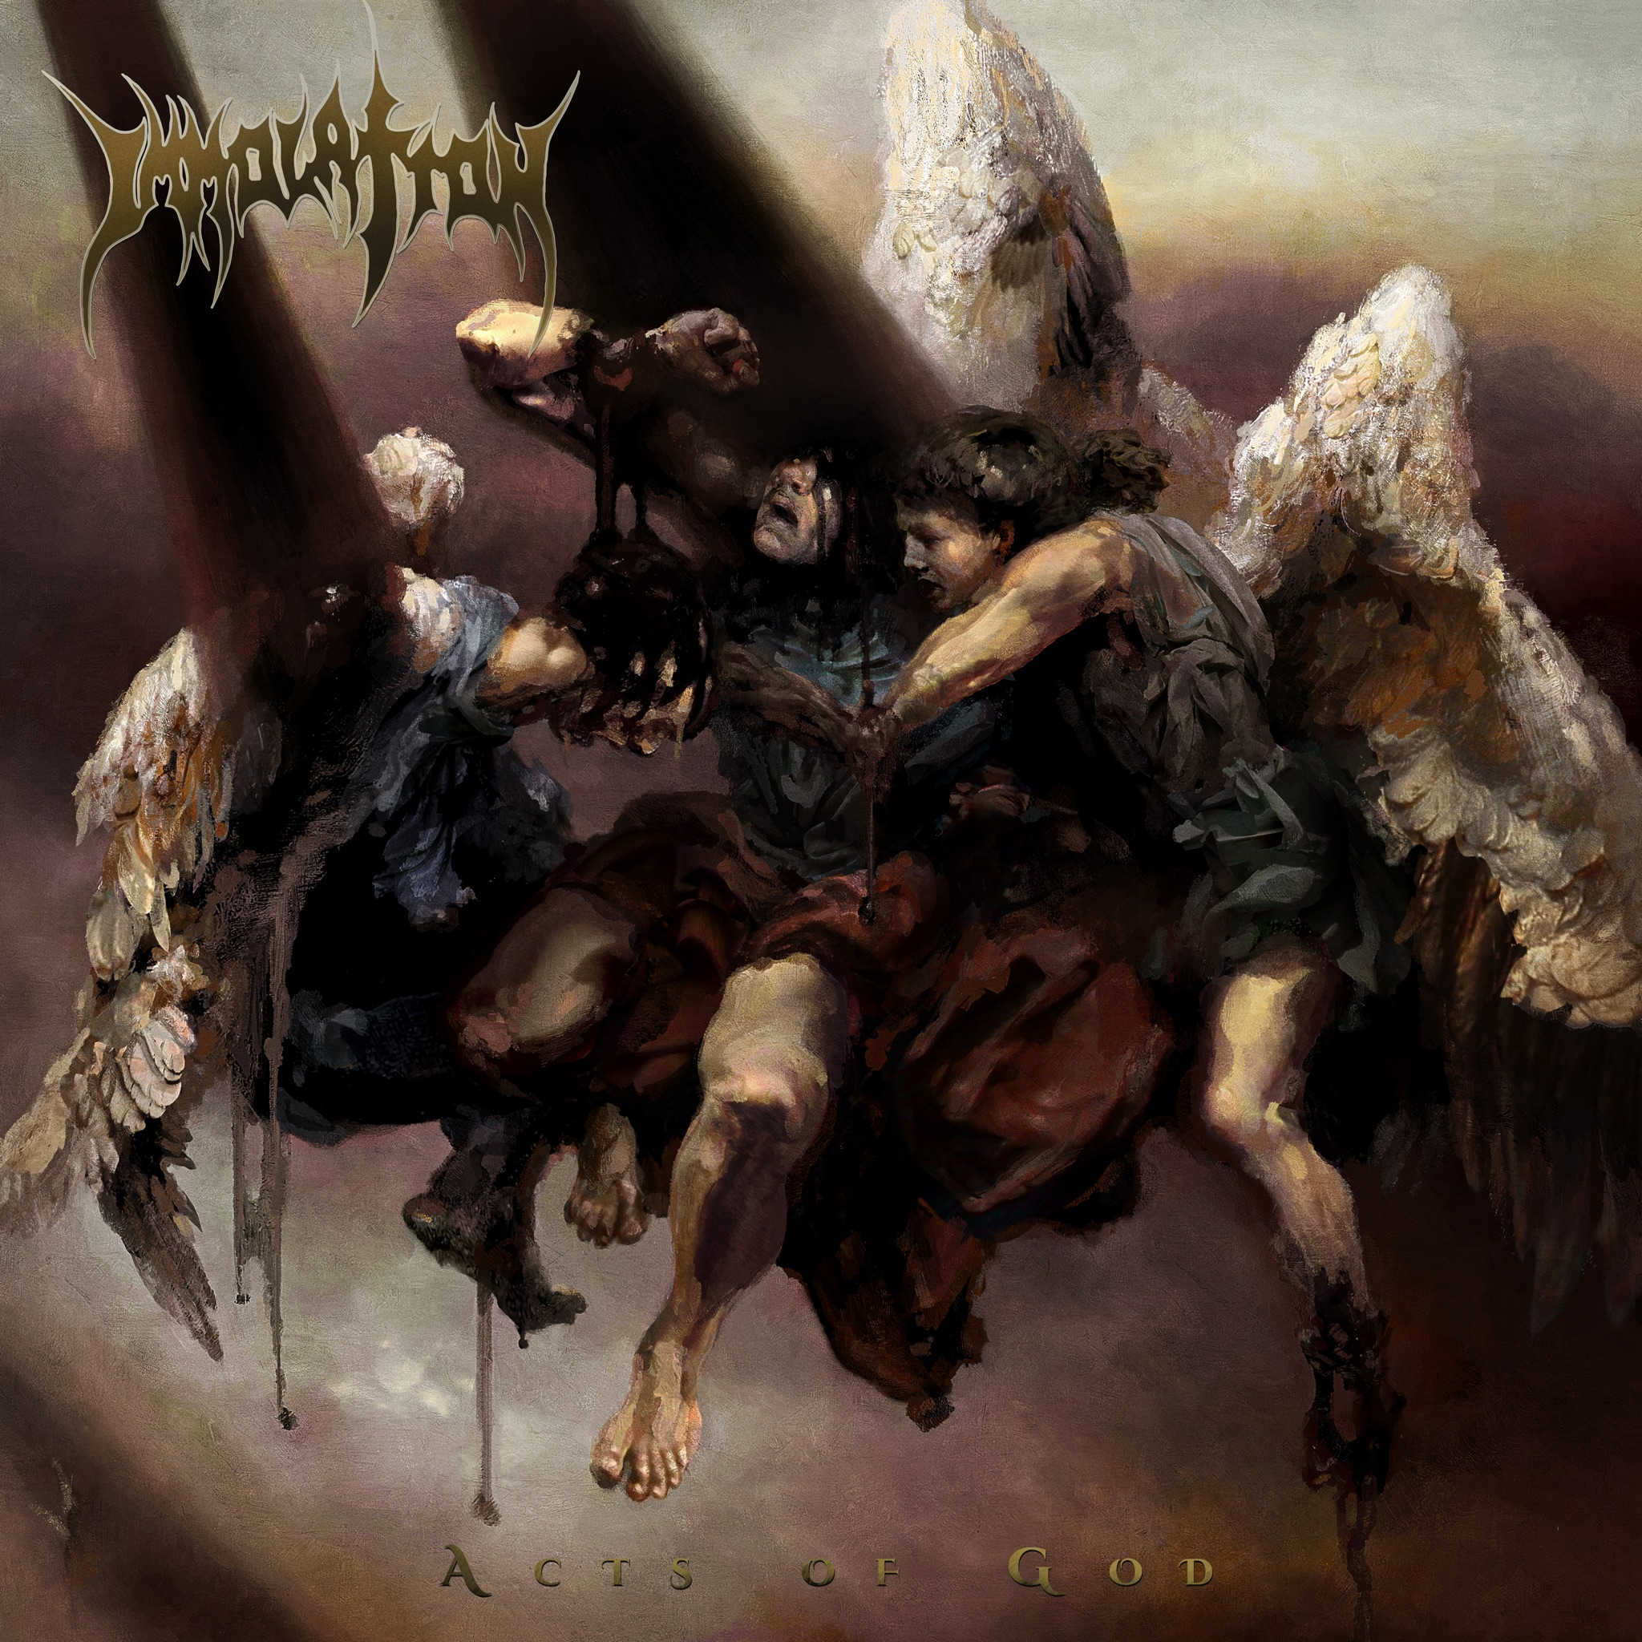

IMMOLATION
ACTS OF GOD
February 18, 2022

Line-up: | IMMOLATION online:
Ross Dolan | Bass, Vocals  Robert Vigna | Guitar  Steve Shalaty | Drums  Alex Bouks | Guitar | www.immolation-store.com  www.facebook.com/immolation  www.instagram.com/immolation_band  www.youtube.com/user/Immolation  www.twitter.com/immolation

Just as one can smell a storm swelling on the horizon, the cataclysmic tremor that is IMMOLATION approaches to unleash its latest, immense creation: ACTS OF GOD. Due to be released in winter of 2022, this 11th studio album serves as the next chapter of IMMOLATION’S Death Metal epic. With 5 long years passed since the most recent studio album, ATONEMENT, ACTS OF GOD vigorously showcases IMMOLATION’s ability to consistently create fascinating sounds, while still keeping their feet firmly rooted in the old school, New York Death Metal for which they are renowned.

Emblazoned with a haunting new masterpiece by artist Eliran Kantor, ACTS OF GOD displays a trifecta of angelic beings desperately trying to prevent one another’s flesh from melting in a blackened light from above. The muted colors and ethereal images will ring familiar to fans of IMMOLATION’s previous album covers. “We wanted this cover to feel much darker; more melancholy and hopeless. The music has always been very dark, and a lot of Kantor’s work had the feeling that we were going for; the semi-surreal colliding with a classic, almost renaissance feel,” explains founder and vocalist/bassist Ross Dolan. “It’s unnerving. It really reflects the music perfectly,” agrees founder and guitarist Robert Vigna.

The album’s third track “The Age Of No Light” is a powerful, hard hitting song with an extreme yet catchy melody. “It’s quick, hits hard, and gets straight to the point” explains Vigna. Consistently changing speeds and patterns throughout, the song is short but remains both dynamic and memorable.

“Blooded” has all the usual IMMOLATION elements: the slow, the fast, the explosive, the big overlaid sections of groovy harmony eventually dropping into evil, ripping guitar work. “It’s a little powerhouse,” describes Vigna, “it’s straightforward, and it has all the elements you would expect from us in a nice, neat package.”

A song like “Immoral Stain” is a slightly mid-paced track with an intense, creepy atmosphere. Equipped with plenty of unusual moments, the beat is catchy, dark, and echoing. Searing guitar starts to recite a story and then quickly begins a conversation with thunderous vocals and a vociferous beat. “That whole section of build up just needed to be done exactly as it is. That’s what makes it sound different and interesting,” describes Vigna. Much like the rest of the album, while the lyrics cover the usual, general topics of genuine evil and the great deception of religion, the specifics are most certainly left to the listener’s interpretation. Fortunately for IMMOLATION fans, there is no shortage of corruption and catastrophe in this world.

Fittingly, the concluding track “Apostle” was the last song written for the album. “Some of those chorus sections have a weird almost dream-like quality,” describes Dolan. Its steadily growing momentum discharges rounds of guitar solos and relentless vocals which eventually lead way to an explosive finale to the album.

The creative journey for ACTS OF GOD began with years of notes, and an abundance of inspiration. With Vigna at the helm of the structural writing as usual, further composing and concepts were tossed back and forth amongst all 4 members. Eventually, they began to skeletonize the beginning of what would become a full length, studio album. While the recording process and entering the studio can be a very sterile experience for some musicians, the ferocity of the demos combined with the expertise of long time friend and recording counterpart Paul Orofino of Millbrook Studios (BLUE OYSTER CULT, BAD CO, GOLDEN EARRING), assured that this would not be an issue for IMMOLATION. “Having such a level of comfort is key,” remarks Dolan. Final touches were brought about on the mixing and mastering by Zack Ohren of Castle Ultimate Studios.

Firmly aligned with Nuclear Blast Records, the often coveted sound of IMMOLATION has reemerged from the depths of a cursed and cruel world to illuminate our minds and ears with exquisite, sonic destruction.

